 | 15.1 Editors - Movie Clip Editor - Header
Table of content
Movie Clip Editor - Header 1
Header right click menus 1
Editortype Menu 1

Movie Clip Editor - Header

The Header contains various menus, navigation elements, settings and tools for the viewport.

The header is divided into two areas. Left menus. Right settings.

The Movie Clip Editor is three editors in one. And the Clip editor in mask mode looks also different. So we need to explain the content for all three editor types plus the sub mode mask.
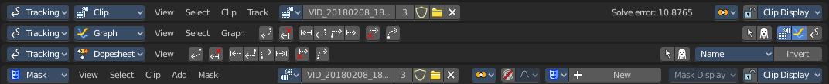

Header right click menus

The general right click menu functionality is explained in chapter 6 Editors introduction.

Editortype Menu
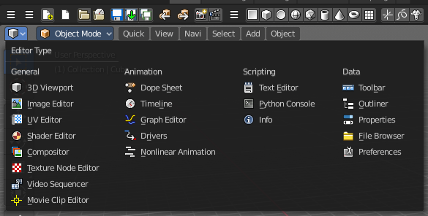
Bforartists is made of several editor types. Headers can display a menu where you can switch to other editor types.

This menu is hidden by default. It is meant to edit the layouts, and should not be necessary for regular work. You can reveal it in the header right click menu.

